**Lecture 30 – Ecology**

* Ecology (oikos + logos): scientific study of interactions between ( ) and

( )

* Subdisciplines within ecology
  + Oragnismal ecology: ( ) and their environments
  + Population ecology: ( ) and their environments
  + Community ecology: Biotic interactions between ( )
  + Ecosystem ecology: Energy flow and ( ) cycling
  + Landscape ecology: Interactions among ( )
  + Global ecology: ( )
* An organism’s environment is determined by both abiotic and biotic factors

Abiotic: ( ) Biotic: ( )

Physical Prey

Chemical Competitors

Geological Predators

Interaction determines ( ) and ( ) of organisms

* ( ) is a long-term, prevailing weather condition in a particular area
  + Main components: temperature, precipitation, sunlight, wind
  + ( ): global, regional, local level
  + ( ): very fine patterns (e.g. fallen logs)
* Incidence of solar radiation drives global climate (Understand why there are differences in global climate, Fig. 52.2)
  + There is latitudinal variation in sunlight intensity
* Intensity of solar radiation varies seasonally because earth is ( ) on its axis relative to its plane of orbit around the sun (Fig. 52.1)
* Intense solar radiation near the equator initiates a global pattern of ( ) and

( ) (Fig. 52.3)

* 30oN and 30oS have ( ) climate, often associated with desert
* Understand why.
* Bodies of water, mountains, and changing angle of the sun affect local climate
  + Because of the high specific heat of water, oceans and large lakes tend to moderate the climate of nearby land.
* Small organisms are affected by small-scale climate ( )
  + Shade, evaporation, changing wind pattern, etc.
* ( ) are major terrestrial or aquatic life zones
* Terrestrial biomes characterized by ( )
  + Terrestrial biomes show strong latitudinal patterns
  + ( ) and ( ) characterize terrestrial biomes (Fig. 52.10)

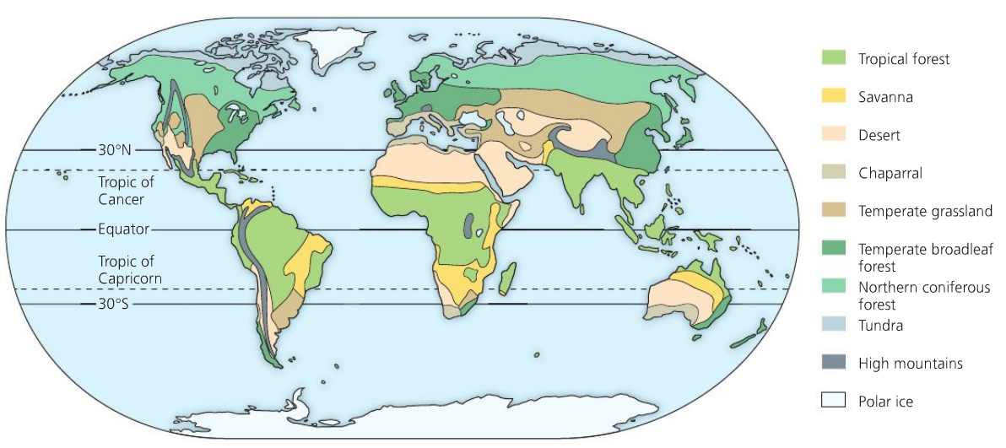

* Tropical Forest
  + Distribution: ( ) regions
  + Precipitation: ( ) precipitation (> 200 cm/year)
  + Temperature: ( ) temperature (25-29oC) year-round
  + Other attributes: ( ) biodiversity
* Savanna
  + Distribution: ( ) regions
  + Precipitation: seasonal rainfall (30-50 cm/year)
  + Temperature: ( ) (24-29oC) year-round
  + Other attributes: grasses and small non-woody plants, scattered trees, large herbivores
* Desert
  + Distribution: bands near ( )o north and south latitude
  + Precipitation: ( ) precipitation (less then 30 cm/year)
  + Temperature: variable (high as 50oC, low as -30oC)
  + Other attributes: plants adapted for ( ) environments
* Chaparral
  + Distribution: midaltitude ( ) regions (*matorral* in Spain and Chile, *maquis* in France, *fynbos* in South Africa)
  + Precipitation: seasonal precipitation (30-50 cm/year)
  + Temperature: ( ) summer, ( ) rest of the year
  + Other attributes: shrubs and small trees, high plant diversity, high diversity of small mammals
* Temperate Grassland
  + Distribution: ( ) regions (*Great Plains* in North America, *veldts* in South Africa, *pampas* in Argentina, *steppes* in Russia)
  + Precipitation: seasonal precipitation (30-100 cm/year)
  + Temperature: ( ) summer, ( ) winter
  + Other attributes: grasses and forbs, large grazers, suitable for ( )
* Northern Coniferous Forest
  + Distribution: northern North America and Eurasia (*taiga*), largest terrestrial biomes
  + Precipitation: annual precipitation from 30-70cm
  + Temperature: long and cold winter
  + Other attributes: conifers, migratory birds, moose, brown bears, etc.
* Temperate Broadleaf Forest
  + Distribution: midaltitudes in Northern Hemisphere, New Zealand, Australia
  + Precipitation: 70-200 cm/year
  + Temperature: Four distinct seasons, summer hot and humid
  + Other attributes: ( ) trees, vertical layers within the forest
* Tundra
  + Distribution: expansive areas of the Arctic (20% of Earth’s land surface)
  + Precipitation: 20-60 cm/year
  + Temperature: long and cold winter, short and chilly summer
  + Other attributes: ( ), caribou, reindeer
* Aquatic biomes characterized by ( )
* Many aquatic biomes are physically and chemically ( ) (layered)
  + Based on light penetration: ( ) vs. ( )
  + Based on distance from shore and water depth: littoral vs. limnetic (freshwater), intertidal vs. neritic vs. oceanic (marine)
  + Based on environment: ( ) vs. ( ) (freshwater), pelagic vs. benthic vs. abyssal (marine)

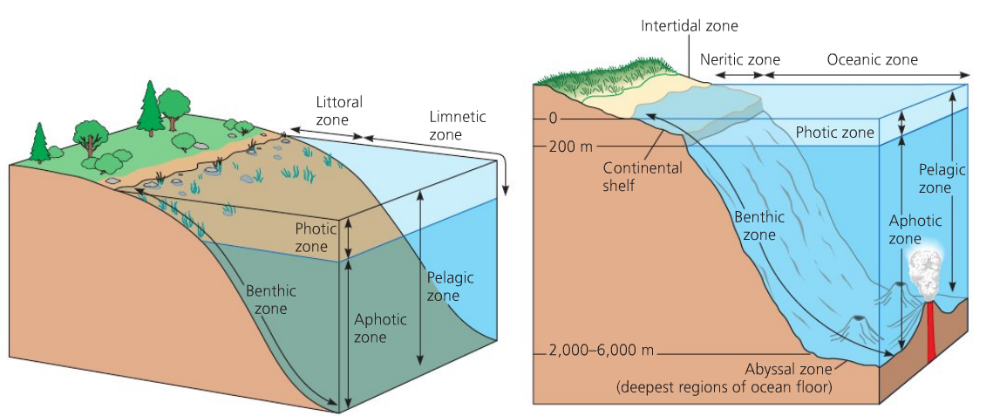

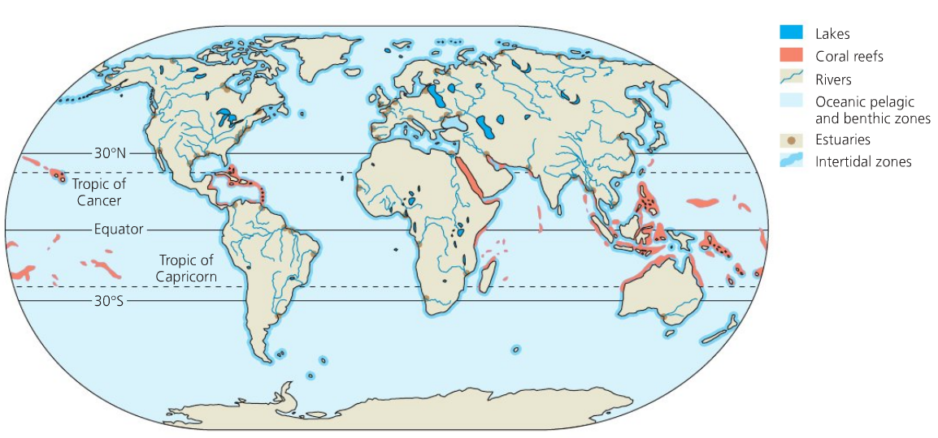

* Lakes
  + Physical: standing bodies of water
  + Chemical: salinity, O2 concentration, nutrient content vary greatly
  + Other attributes: variable
* Wetlands
  + Physical: ( ) by water periodically
  + Chemical: a high capacity to ( ) dissolved nutrients and chemical pollutants
  + Other attributes: support plants adapted to water-saturated soil, one of the most productive biomes
* Streams and rivers
  + Physical: ( )
  + Chemical: Headwater high in O2, downstream with organic enrichment
  + Other attributes: great diversity of fishes and invertebrates
* Estuaries
  + Physical: a ( ) area between river and sea
  + Chemical: salinity varies (depending on the tide level)
  + Other attributes: saltmarsh grasses, algae, oysters, crabs, and many fishes
* Intertidal zones
  + Physical: periodically submerged and exposed by the tides
  + Chemical: ( ) O2 and nutrient level
  + Other attributes: high diversity and biomass of marine algae, animals adapted for

( ) to hard substrate

* Oceanic pelagic zone
  + Physical: vast realm of open blue water; 70% of Earth’ surface
  + Chemical: ( ) O2 level, generally ( ) nutrient concentration
  + Other attributes: phytoplankton, zooplankton, many free-swimming animals
* Coral reefs
  + Physical: formed from calcium carbonate skeletons of corals, sensitive to

( )

* + Chemical: require high O2 level
  + Other attributes: exceptionally high ( ) (fishes and invertebrates)
* Marine benthic zone
  + Physical: seafloor below surface waters, cold, high water pressure
  + Chemical: sufficient O2
  + Other attributes: deep-sea hydrothermal vents support ( ) (oxidize H2S)